Project Report

On

**“Online Discussion Panel”**

Submitted for the partial fulfillment of the requirement for the degree of

**Bachelor of Technology**

in

**Computer Science & Engineering**

**By**

**TANZEEL AHMAD MUJAHID Reg. No: 1501287165**

**Supervised/Guided By:**

Prof. PRASANTA KUMAR DAS



**GANDHI INSTITUTE FOR TECHNOLOGICAL ADVANCEMENT**

**BHUBANESWAR**

**OCTOBER 2018**



**Department of Computer Science & Engineering**

**Gandhi Institute for Technological Advancement, Bhubaneswar**

## Ref no:…………………… Date:…………………..



**Certificate**

This is to certify that the project report entitled “ONLINE DISCUSSION PANEL” submitted by Mr. TANZEEL AHMAD MUJAHID, Reg No.1501287165 is an authentic work carried out by him/her at GITA under my guidance. The matter embodied in this project work has not been submitted earlier for the award of any degree or diploma to the best of my knowledge and belief.

**Prof. (Dr.) Tarini Prasad Panigrahy Prof. PRASANTA KUMAR DAS**

**(H.O.D., Dept. of CSE) (Supervisor)**



**Department of Computer Science & Engineering**

**Gandhi Institute for Technological Advancement, Bhubaneswar**



**ACKNOWLEDGEMENT**

*I express my deepest sense of gratitude to our beloved professor (Late)****Prof.(Dr.)Manoranjan Pradhan****, Ex-Head of Department, Computer Science & Engineering for his initiative and constant inspiration.*

*I also express and gratitude* ***to Prof.Name of the Supervisor****, project supervisor for his guidance and constant support.*

*I also take this opportunity to thank* ***Prof. (Dr.) Tarini Prasad Panigrahy,*** *head of Department, Computer Science & Engineering, for his constant support and timely advice.*

*Lastly, words run to express my gratitude to all the faculties of the CSE Dept. and friends for their support and cooperation, constructive criticism and valuable suggestion during preparation of this project report.*

*Thanking All….*

*.*

(Full signature of the student)

**TANZEEL AHMAD MUJAHID**

Reg. No: 1501287165

Email-id: tanzeel0121@gmail.com

**Abstract**

The 21st century has brought great developments and advancements in the field of technology. These advancements have also bought many challenges and require approaches to handle these challenges. Now-a-days in a fast running world everyone is finding a proper solution to their problems and discussion is the way to find it but at the same time everyone is lacking of time for their other works and discussions takes time whether it is telephonic discussion or face to face meeting. Even getting the right solution at the particular time and relying on them is also not a good solution.

This project is aimed at developing online panel for the group discussion. This is a web, based tool. Any user can post the doubts topics and can reply for the other user doubts. The user can invites others for discussion and submit /query. This is useful for a small office, school or a department or for that matter any group who is interested to organize it effectively. Facility to share the resource and post articles that can be viewed by registered user.

**Functional components of the project**

Following are the requirements which can be used to derive functional components:

* Users need to register.
* Facility to post topics for the discussion.
* Facility to view previous the discussion by topics.
* Administrator has privilege to edit, delete user’s profile.
* Administrator has privilege to add, edit and delete questions and their categories.

**Table of Contents**

|  |  |  |
| --- | --- | --- |
| **Chapter** | **Contents** | **Page** |
| **1** | **Introduction** | 7 |
|  | 1.1: Problem Statement | 7 |
|  | 1.2 : Project Objective | 7 |
|  | 1.3 : Project Scope | 7 |
|  | 1.4: Assumptions | 7 |
|  | 1.5: Constraints | 8 |
| **2** | **Feasibility Study** | 8 |
|  | 2.1: Technical Feasibility | 8 |
|  | 2.2: Economical Feasibility | 8 |
|  | 2.3: Legal Feasibility | 8 |
|  | 2.4: Operational Feasibility | 8 |
| **3** | **Requirement Analysis & Specification** | 9 |
|  | 3.1: Hardware Requirement | 9 |
|  | 3.2: Software Requirement | 9 |
|  | 3.3: Modules of the system | 9 |
| **4** | **Coding Specification** | 11 |
|  | 4.1: Features of common runtime language | 11 |
| **5** | **Design** | 12 |
|  | 5.1: Input Design | 12 |
|  | 5.2: Output Design | 12 |
|  | 5.3: Data Flow Diagram | 13 |
|  | 5.4: E-R-Diagram | 14 |
| **6** | **Testing** | 15 |
|  | 6.1: Unit Testing | 15 |
|  | 6.2: Integration Testing | 15 |
|  | 6.3: Validation Testing | 15 |
|  | 6.4: Verification Testing | 15 |
| **7** | **Maintenance** | 16 |
| **8** | **System Implementation** | 16 |
|  | 8.1: Scope for future development | 16 |
| **9** | **Conclusion** | 17 |
| **10** | **Appendix** | 18 |
|  | 10.1: Database Structure | 18 |
|  | 10.2: Screenshots – Online Discussion Panel | 20 |

1. **INTRODUCTION**
   1. **Problem Statement**

With highly growing of the telecommunication infrastructures, such as Internet and the development of the high performance have brought about new era of rapid advances in information technology. Internet has become an ocean of information related to every aspect which has existence in this world. The main purpose of this website is to develop a one roof platform for the effective interaction, effective exposure, and a right direction toward communication.

This is a web, based tool. Any user can post the doubts topics and can reply for the other user doubts. The user can invites others for discussion and submit /query. This is useful for a small office, school or a department or for that matter any group who is interested to organize it effectively. Facility to share the resource and post articles that can be viewed by registered user.

**1.2 Problem Objective**

This “online discussion panel” is aimed at developing online form for the group discussion. This is a web-based application to manage group discussion. . This forum provides the platform under one roof to interact with different members which maybe the experts in a particular field or a normal employee for seeking or to give advices. Whenever a question is asked by the end-user to get information, it is received by the administrator. Any user can post the doubts topics and can reply for the other user doubts. There is a centralized database in which all the information is managed. The user can invites others for Discussion and submit query. The administrator has the rights to update the database. Facility to share the resource and post articles that can be viewed by registered user.

**1.3 Project Scope**

The purpose of the online discussion panel system is to create convenient and easy-to-use online discussion for people to seek solution for their problems or doubts. To help people get a solution for their problem by sitting at any place they can post their problems/doubts or can help others on their problems according to their convenience and ease.

**1.4 Assumptions**

One assumption about the product is that it will always be used on personal computers or laptops that have enough performance. If the personal computer or laptop does not have enough hardware resources available for the application, for example the users might have allocated them with other applications; there may be scenarios where the application does not work as intended or even at all. Another assumption is that the internet in all phones of the service provider must work in the same way so that they can receive the request immediately.

**1.5 Constraints**

There are no such constraints while using helpmate. But while operating helpmate the person should have proper internet connections.

1. **Feasibility Study**

Feasibility study is the first step before starting any project. The main aim of feasibility study is to determine whether developing the product is financially and technically feasible or not. In Feasibility study we also test whether the product would be profitable. The Feasibility study involves the analysis of the problem and collection of data which would be input to the system, the processing require to be carried in this data. The output data required to be produced by the system. The collected data are analyzed to arrive at the following:

* 1. **Technical feasibility -** Technical feasibility means whether the project is working in a perfect manner. It means the project must support or perform all the technical functions for which it is implemented. The project “ONLINE DISCUSSION PANEL” through PHP TECHNOLOGY is technically feasible. This website is well capable of providing a user good interface thus this project is able to work in effective and efficient manner.
  2. **Economical feasibility -** Economical feasibility is a term which is related to estimation of cost required for the project. This project is feasible under the economic condition.
  3. **Legal feasibility -** Legal feasibility means the developing project must be legal. The way by which the product is going to be implemented must be legal. The project must perform a legal task. It must be acceptable worldwide. The project is not going to perform any tasks which are not lie under the condition of law. Thus the project must be legal to use and can be acceptable by the user.
  4. **Operational feasibility -** Operational feasibility means the project must perform its operation perfectly. If the project is working properly then we can say that the project is operational feasibility.

1. **REQUIREMENT ANALYSIS AND SPECIFICATION**

### Hardware Requirement

This section will describe the hardware requirement which is at least necessary to run this website.

* **Processor -** The minimum requirement of processor is at least Pentium IV with900 MHz processing speed. The speed of processor determines the time taken for the execution of the instructions. Higher processing speed leads to faster execution of the instruction.
* **RAM -** There should be minimum 512 MB of RAM available for the smooth functioning of the project. Higher memory leads in better results.
* **Hard disk -** There should be about minimum 40GB of hard disk for smooth functioning of the project and so the recommended hard disk space is 40GB.
* **Cache Memory** - There must be about 512 KB of cache memory so that the accessing time can be better and compilation is easier.

**3.2 Software Requirement**

* **Operating System -** Window XP, 7, 8, 10
* **Front End -** HTML5, CSS3
* **Back End –** PHP, Mysqli
* **Tools -** XAMPP Server, Sublime Text Editor, Mozilla/Chrome Browser

### 3.3 Modules of Online Discussion Panel

The project contains five main modules.

* Category
* Post Question
* Registration
* Answer
* Discover

**Category Module:**

This module is the main module, by selecting the category user can post their questions easily. It helps the user to categorize the question so that he can get answer form the expert users of that category. They can retrieve the answers for their questions from the different users. It also user to find the answer of related question in that category.

**Post Question Module:**

This module is mainly for the registered users. As the Administrator has to know who has posted the questions the user is registered here. When the user asks the answer of the questions is replied by either the administrator or the admin-connected user. These registered users alone can post their question in detailed manner. The end-user is provided with the access rights which managed by the administrator. The access to the database is provided to the end-user according to these rights only.

**Registration Module:**

From this module user can get registered in the panel by filling up the registration form. This Module helps to give the detailed information about the newly entered user.

**Answer Module:**

Each and every posted question will get the exact answer from the Discussion Panel team and also they can get a lot of answers from the different user. When the administrator replies to the questions the admin-connected user will cache them in the memory.

**Discover Module:**

Users can answer the questions which are posted in this site. Both registered and non registered user is benefited over this module. They can also view the answers posted in this site. This will helpful when the user again ask about the same questions the admin-connected will the reply the answer of the question directly from the cache-memory.

1. **CODING SPECIFICATION**

The Project entitled “Online Discussion Panel” is developed using HTML5 and CSS3 as front end and PHP and mysqli as back end.

**PHP** – It is a comprehensive, object, oriented collection of reusable types used to develop applications ranging from traditional command, line or graphical user interface (GUI). **It is a scripting language**that was designed and built for the web—one reason it has a clear advantage when developing web-based applications. It’s agile and has great runtime, and with Apache, it can be incredibly affordable to get up and running.

* 1. **Features of common runtime language**

The common language runtime manages memory: thread execution, code execution0 code safety verification, compilation and other system services these are all run on CLR.

* Security
* Robustness
* Productivity
* Performance

**Security** - The runtime enforces code access security. The security features of the runtime thus enable legitimate internet, deployed software to be exceptionally feature rich. With regards to security, managed components are awarded varying degrees of trust0depending on a number of factors that include their origin to perform file, access operations, registry-access operations, or other sensitive functions.

**Robustness** - The runtime also enforces code robustness by implementing a strict type, and code, verification infrastructure called the common type system (CTS). The CTS ensures that all managed code is self, describing. The managed environment of the runtime eliminates many common software issues.

**Productivity** - The runtime also accelerates developer productivity. For example, programmers can write applications in their development language of choice, yet take full advantage of the runtime, the class library, and components written in other languages by other developers.

**Performance** - The runtime is designed to enhance performance. Although the common language runtime provides many standard runtime services, managed code is never interpreted. A feature called just-in-time (JIT) compiling enables all managed code to run in the native machine language of the system on which it is executing. Finally, the runtime can be hosted by high, performance, server side applications such as XAMPP Server.

1. **DESIGN**

Design is multi-step process that focuses on data structure software architecture, procedural details, (algorithms etc) and interface between modules. The design process also translates the requirements into the presentation of software that can be accessed for quality before coding deigns. Computer software design changes continuously as new methods better analysis and broader understanding evolved. Software design is at relatively early stage in its revolution. Therefore, Software design methodology lacks the depth, flexibility and quantitative nature that are normally associated with more classical engineering disciplines. However techniques for software designs do criteria for design qualities are available and design notation can be applied.

**5.1 Input Design -** Input design is the process of converting user, originated inputs to a computer-based format. Input design is one of the most expensive phases of computerized system and is often the major problem of a system.

In the project input design is made on various web forms with various methods.

For example, in the admin form, the empty username and password is not allowed. The user if exists in the database, input is considered to be invalid and is not accepted.

**5.2 Output Design -** Output design generally refers to the results and information that are generated by the system for many end-users; output is the main reason for developing the system and the basis on which they evaluate the usefulness of the application.

In the project, once question are posted, it stores in to the database. The questions are viewed and also the user who needs the details about the question can register and see the related answer which is to be posted this site.

**5.3 DATA FLOW DIAGRAM**

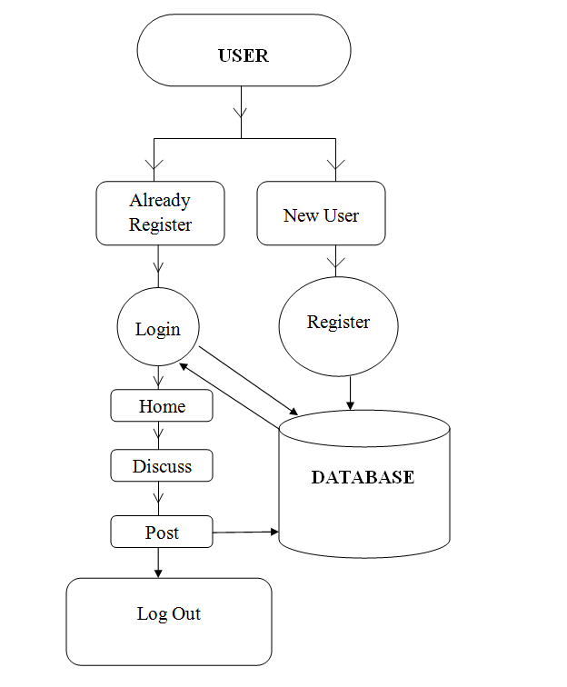

**5.4 E-R DIAGRAM**

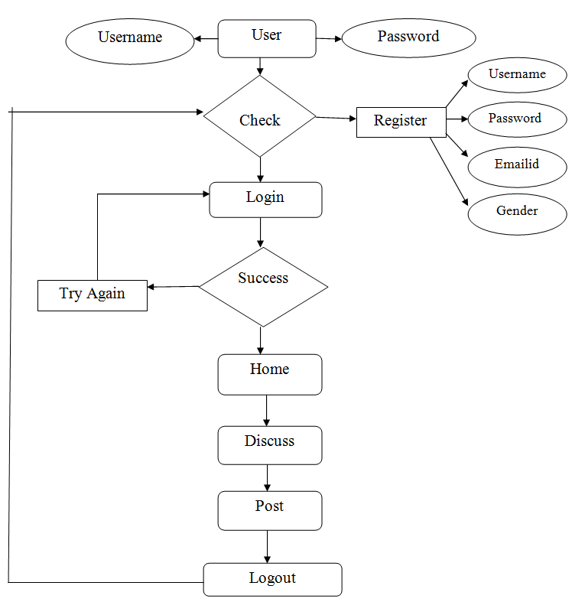

1. **TESTING**
   1. **Unit Testing -** The procedure level testing is made first. By giving proper inputs, the errors occurred are noted and eliminated. Then the web for level testing is made. For example storage of data to the table in the correct manner. The dates are entered in wrong manner and checked. Wrong emailid and website URL (Universal Resource Locator) is given and checked.
   2. **Integration Testing -** Testing is done for each module. After testing all the include the modules are integrated and testing of the final system is done with the test data specially designed to show that the system will operate successfully in all its aspects conditions. Thus the system testing is a confirmation that all is correct and an opportunity to show the user that the system works.
   3. **Validation Testing -** The final step involves Validation testing, which determines whether the software function as the user expected. The end user rather than the system developer conduct this test most software developers as a process called “Alpha and Beta Testing” to uncover that only the end user seems able to find. The compilation of the entire project is based on the full satisfaction of the end users. In the project validation testing is made in various forms. In registration form Email-id, phone number and also mandatory fields for the user is verified.
   4. **Verification Testing –** Verification is the fundamental concept in the software design. This is a bridge between customer requirements and an implementation that satisfies those requirements. This is verifiable if it can be demonstrated that the testing results in an implementation that satisfies customer requirements.

In adequate testing or non-testing leads to error that may appear few months later. This will create two problems:

1. Time delay between cause and appearance of the problem.
2. The effect of the system errors on file and records within the system.
3. **MAINTENANCE**

The objectives of this maintenance work are to make sure that the system gets into work all time without any bug. Provision must be for environmental changes which may affect the computer or software system. This is called the maintenance of the system. Now a day there is the rapid change in the software world. Due to this rapid change, the system should be capable of adapting these changes. In our project the process can be added without affecting other parts of the system. Maintenance plays a vital role. System modification and liable implementation after it. This system has been designed to favor all new changes. Doing this will not affect the systems performance or its accuracy.

1. **SYSTEM IMPLEMENTATION**

Implementation is the most crucial stage in achieving a successful system and giving the user’s confidence that the new system is workable and effective. Implementation of a modified application to replace an existing one. This type of conversation is relatively easy to handle, provide there are no major changes in the system.

Each program is tested individually at the time of development using the data and has verified that this program linked together in the was specified in the programs specification, the computer system and its environment is tested to the satisfaction of the user. The system that has been developed is accepted and proved to be satisfactory for the user. And so the system is going to be implemented very soon. A simple operating procedure is included so that the user can understand the different functions clearly and quickly.

Initially as a first step the executable form of the application is to be created and loaded in the common server machine which is accessible to the entire user and the server is to be connected to a network. The final stage is to document the entire system which provides components and the operating procedures of the system.

* 1. **Scope for future development**

Every application has its own merits and demerits. The project has covered almost all the requirements. Further requirements and improvements can easily be done since the coding is mainly structured or modular in nature. Changing the existing modules or adding new modules can append improvements. Further enhancements can be made to the application, so that the website functions very attractive and useful manner than the present one.

1. **CONCLUSION**

It is concluded that the application works well and satisfy the both registered and registered. The application is tested very well and errors are properly debugged. The site is simultaneously accessed from more than one system.

The site works according to the restrictions provided in their respective browsers. The speed of the transactions become more enough now. In this site the user can search the appropriate answers for their questions.. The- can view their favorable questions, articles and inventions.

1. **APPENDIX**

**10.1 Database name: ‘dbforum’**

|  |  |
| --- | --- |
| **TABLE NAME** | **TABLE STRUCTURE** |
| category | CREATE TABLE `category` (  `cat_id` int(12) NOT NULL AUTO_INCREMENT,  `category` varchar(200) DEFAULT NULL,  PRIMARY KEY (`cat_id`) ) ENGINE=InnoDB AUTO_INCREMENT=9 DEFAULT CHARSET=latin1 |
| tblaccount | CREATE TABLE `tblaccount`(  `accnt_Id` int(11) NOT NULL AUTO_INCREMENT,  `username` varchar(255) DEFAULT NULL,  `password` varchar(255) DEFAULT NULL,  `user_Id` int(11) DEFAULT NULL,  PRIMARY KEY (`accnt_Id`),  KEY `user_Id` (`user_Id`),  CONSTRAINT `tblaccount_ibfk_1` FOREIGN KEY (`user_Id`) REFERENCES `tbluser` (`user_Id`) ON DELETE CASCADE ON UPDATE CASCADE ) ENGINE=InnoDB AUTO_INCREMENT=6 DEFAULT CHARSET=latin1 |
| tblcomment | CREATE TABLE `tblcomment` (  `comment_Id` int(11) NOT NULL AUTO_INCREMENT,  `comment` varchar(255) DEFAULT NULL,  `post_Id` int(11) DEFAULT NULL,  `datetime` datetime DEFAULT NULL,  `user_Id` int(12) DEFAULT NULL,  PRIMARY KEY (`comment_Id`),  KEY `user_Id` (`user_Id`),  KEY `post_Id` (`post_Id`),  KEY `user_Id_2` (`user_Id`),  CONSTRAINT `tblcomment_ibfk_1` FOREIGN KEY (`user_Id`) REFERENCES `tbluser` (`user_Id`) ON DELETE CASCADE ON UPDATE CASCADE,  CONSTRAINT `tblcomment_ibfk_2` FOREIGN KEY (`post_Id`) REFERENCES `tblpost` (`post_Id`) ON DELETE CASCADE ON UPDATE CASCADE ) ENGINE=InnoDB AUTO_INCREMENT=3 DEFAULT CHARSET=latin1 |
| tblpost | CREATE TABLE `tblpost` (  `post_Id` int(11) NOT NULL AUTO_INCREMENT,  `title` varchar(255) DEFAULT NULL,  `content` text,  `datetime` datetime DEFAULT NULL,  `cat_id` int(12) DEFAULT NULL,  `user_Id` varchar(245) DEFAULT NULL,  PRIMARY KEY (`post_Id`),  KEY `cat_id` (`cat_id`),  KEY `user_Id` (`user_Id`),  CONSTRAINT `tblpost_ibfk_1` FOREIGN KEY (`cat_id`) REFERENCES `category` (`cat_id`) ON DELETE CASCADE ON UPDATE CASCADE ) ENGINE=InnoDB AUTO_INCREMENT=5 DEFAULT CHARSET=latin1 |
| tbluser | CREATE TABLE `tbluser` (  `user_Id` int(11) NOT NULL AUTO_INCREMENT,  `fname` varchar(255) DEFAULT NULL,  `email` varchar(255) DEFAULT NULL,  `gender` varchar(255) DEFAULT NULL,  `mob_number` varchar(10) NOT NULL,  PRIMARY KEY (`user_Id`) ) ENGINE=InnoDB AUTO_INCREMENT=6 DEFAULT CHARSET=latin1 |
| tbladmin | CREATE TABLE `tbladmin` (  `Id` int(11) NOT NULL AUTO_INCREMENT,  `uname` varchar(255) DEFAULT NULL,  `pwd` varchar(255) DEFAULT NULL,  PRIMARY KEY (`Id`) ) ENGINE=InnoDB AUTO_INCREMENT=2 DEFAULT CHARSET=latin1 |

**10.2 Screenshots – Online Discussion Panel**

index.php

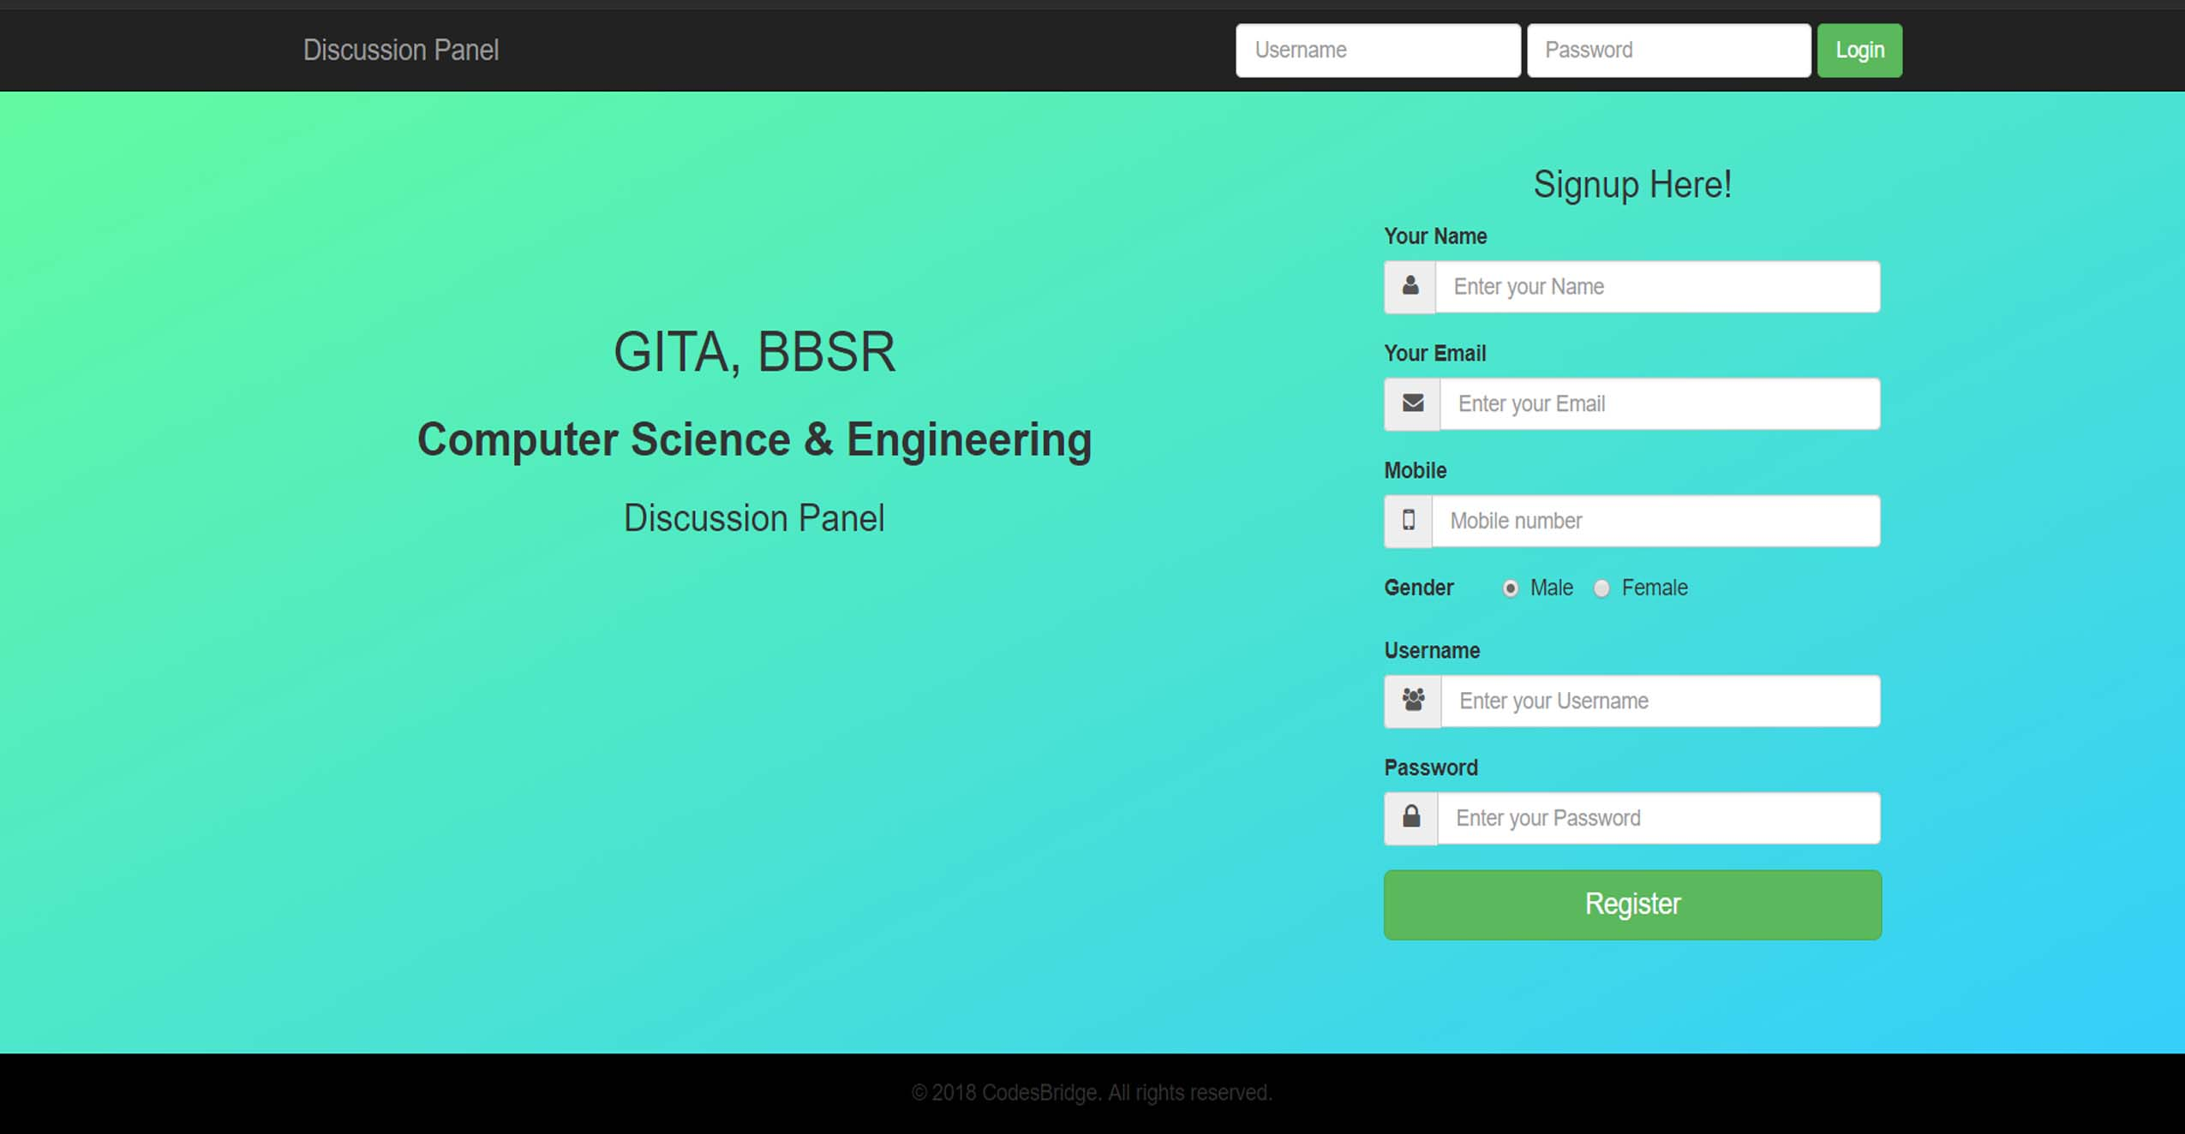

USER FUNCTIONALITIES

Pages/home.php

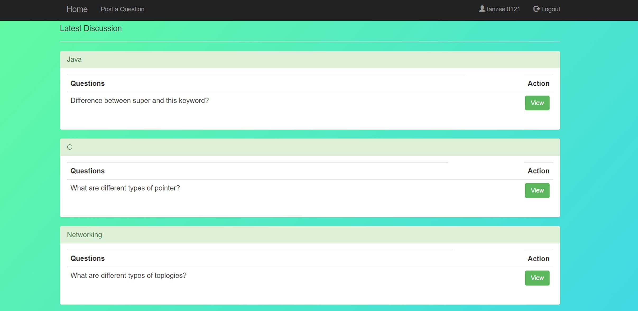

Pages/content.php

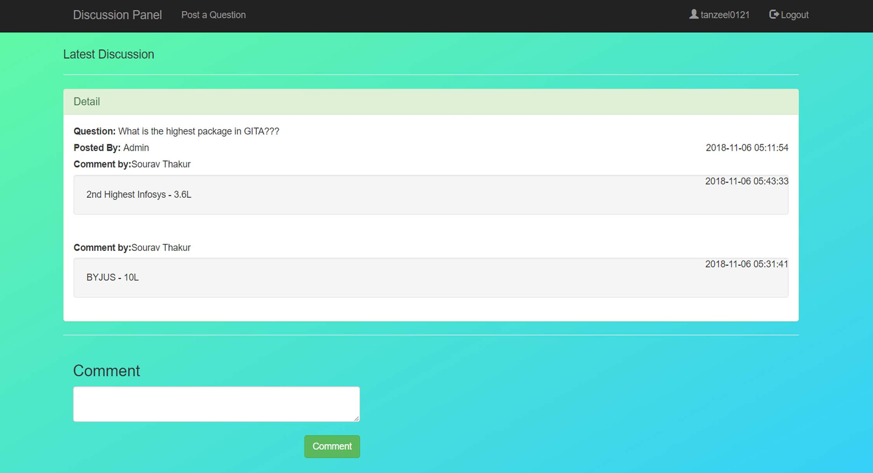

ADMIN FUNCTIONALIIES

admin/login.php

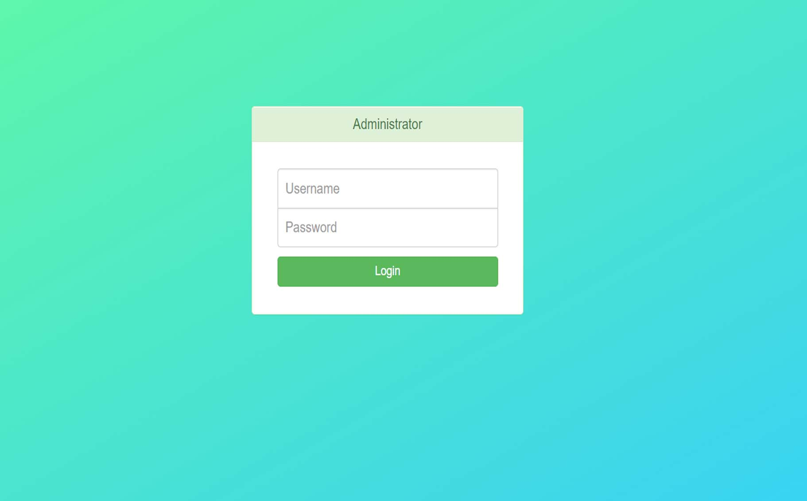

admin/index.php

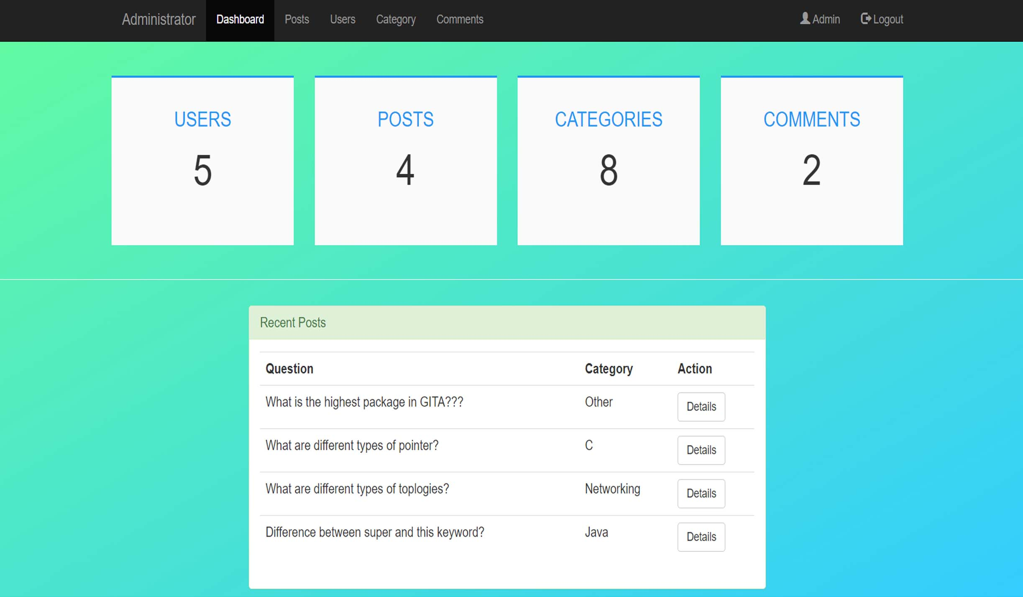

admin/post.php

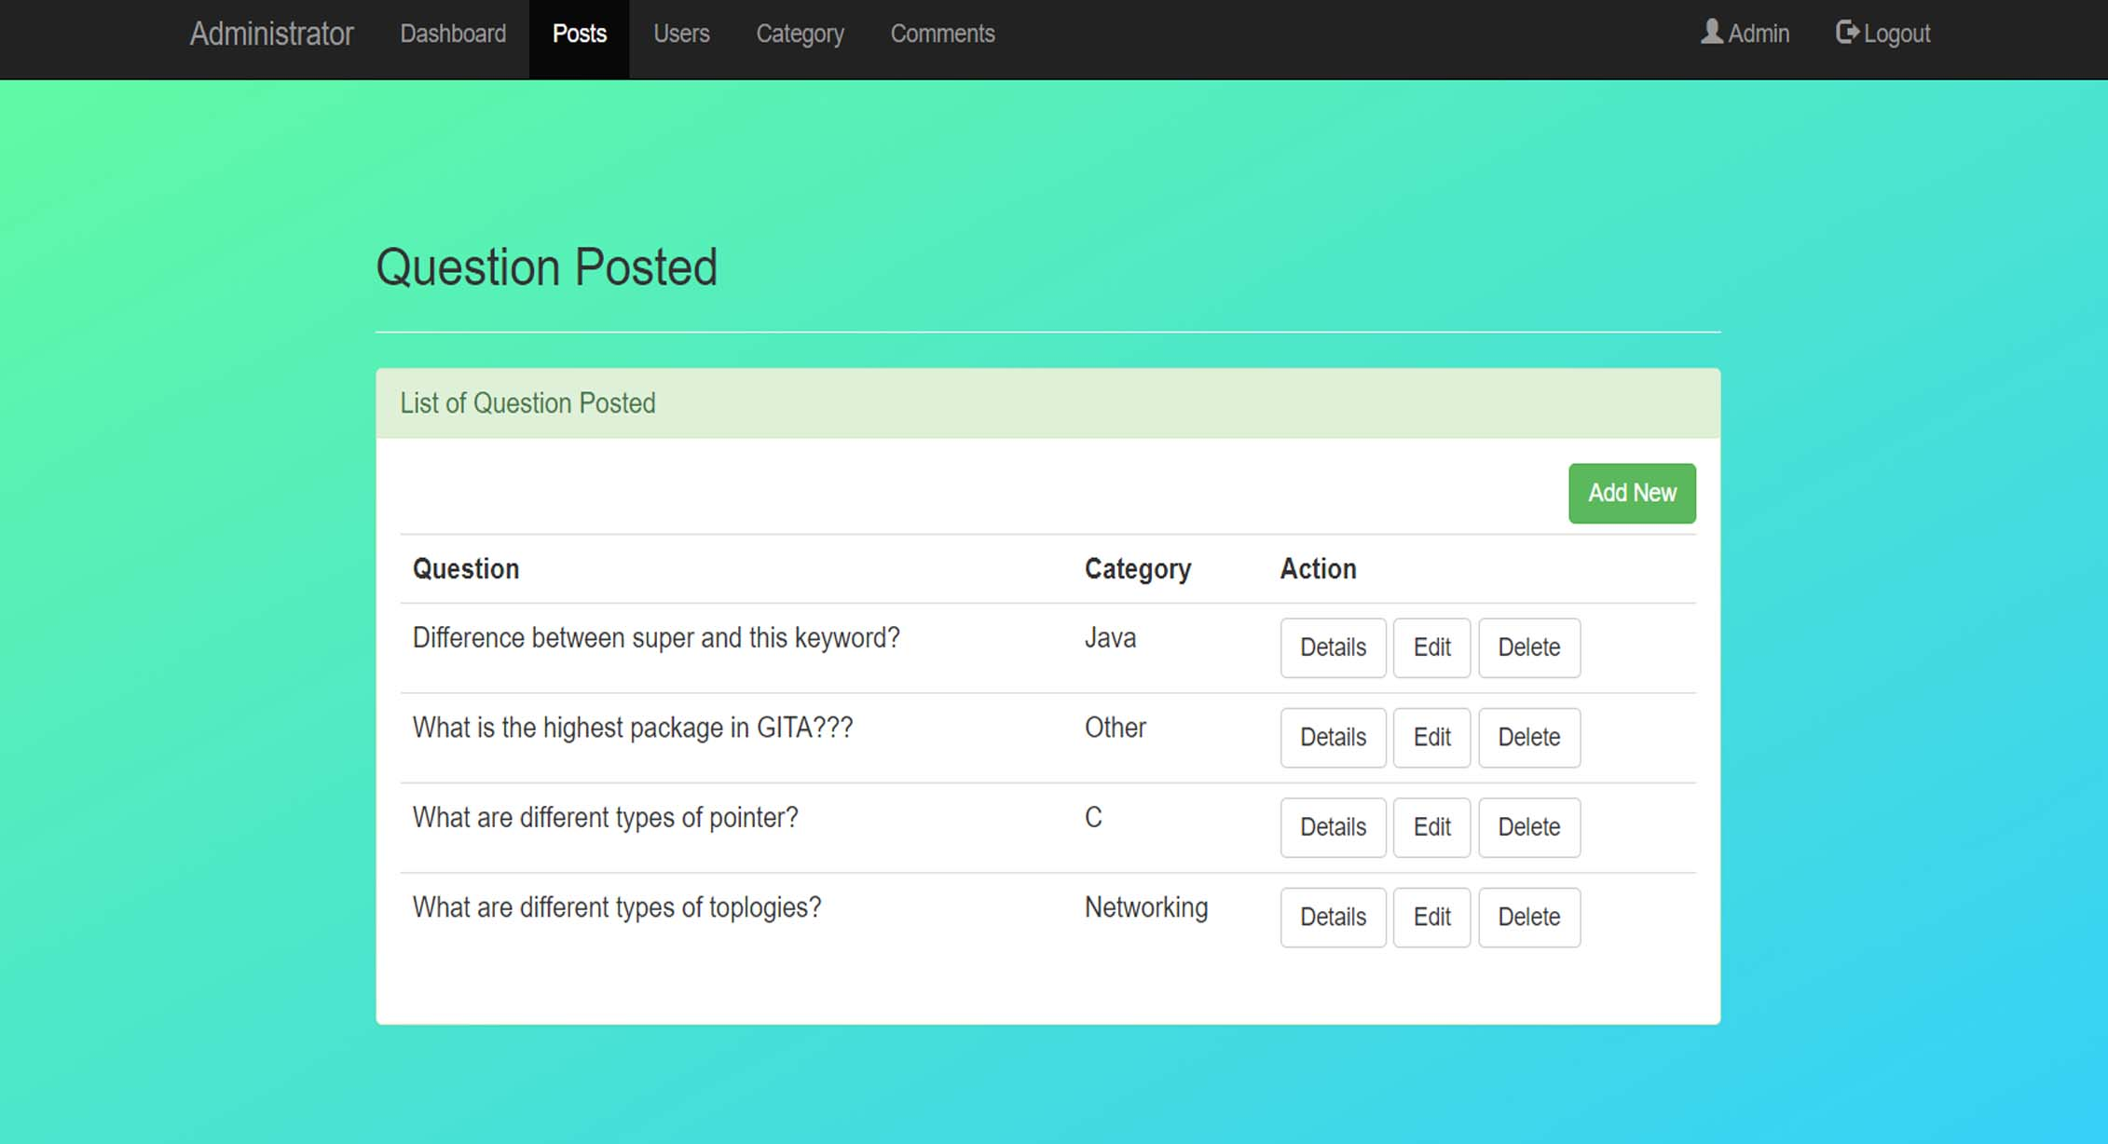

admin/post.php **🡪**Add New

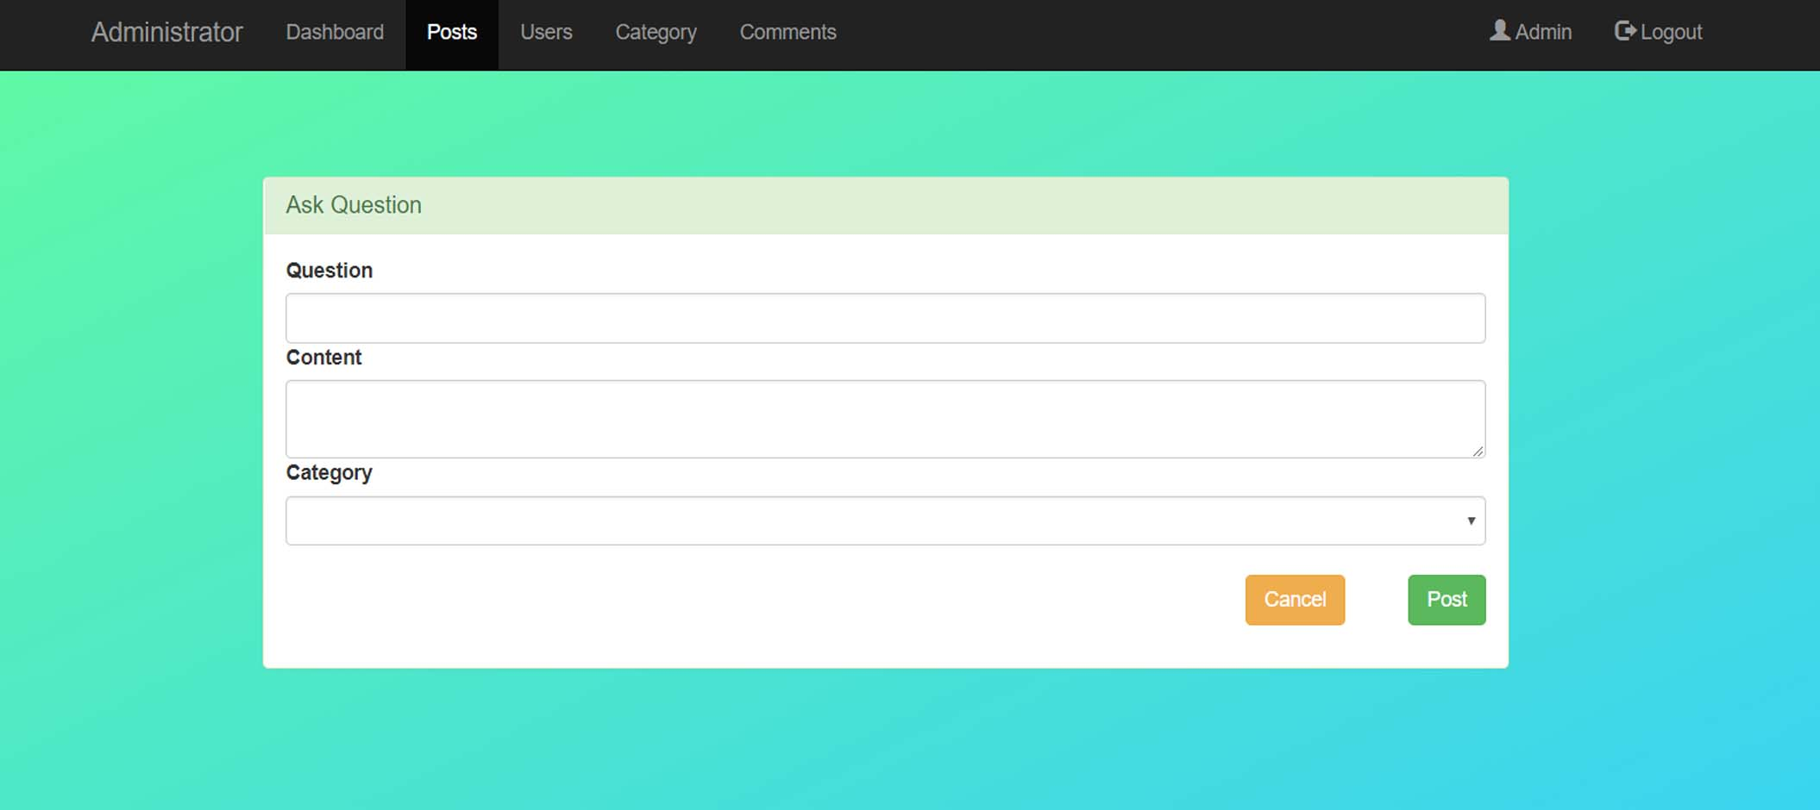

admin/user.php

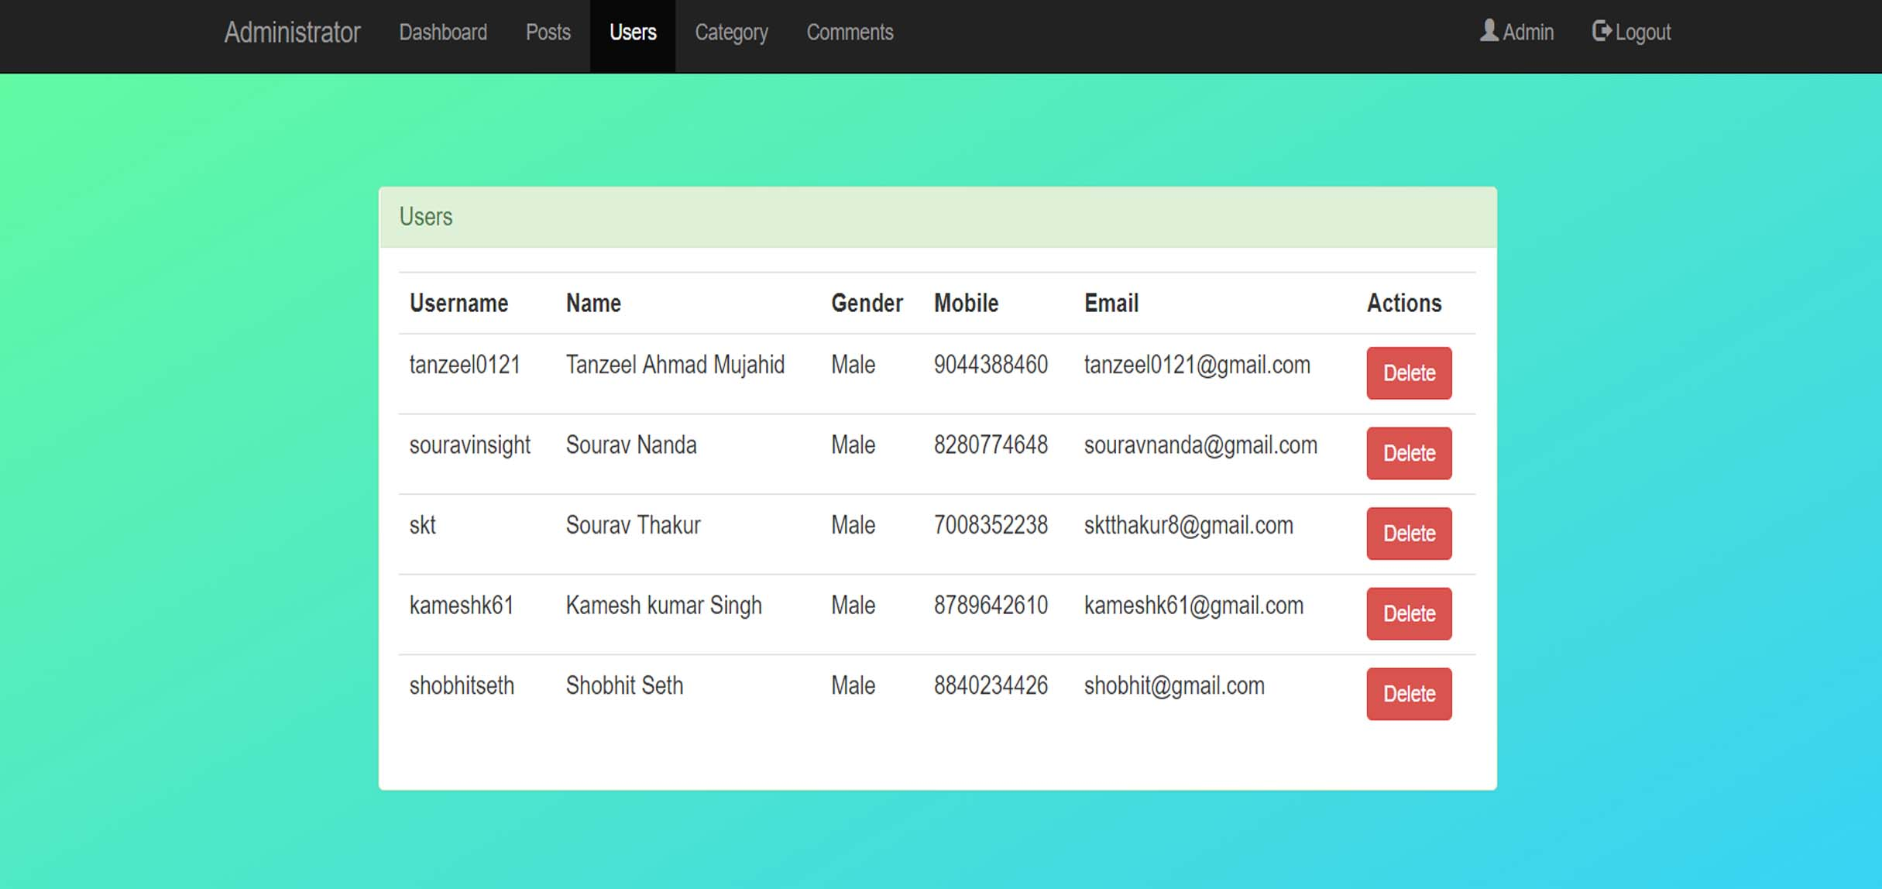

admin/category.php

